ASSIGNMENT – 10.2
NAME : AJMERA RUCHITHA
HALLTICKET NUMBER : 2303A52365
BATCH : 33
Task Description -1(Error Detection and Correction)
Task:
Use AI to analyze a Python script and correct all syntax and logical
errors.
Sample Input Code:
def calculate_total(nums)
sum = 0
for n in nums
sum += n
return total
Expected Output-1:
Corrected and executable Python code with brief explanations of the
identified syntax and logic errors.
PROMPT :
Act as a senior Python code reviewer.
Analyze the following Python script and:
1. Identify all syntax errors.
2. Identify all logical errors.
3. Explain each issue briefly.
4. Provide corrected and fully executable Python code.
5. Follow PEP 8 guidelines.

Here is the code:
def calculate_total(nums)
sum = 0
for n in nums
sum += n
return total
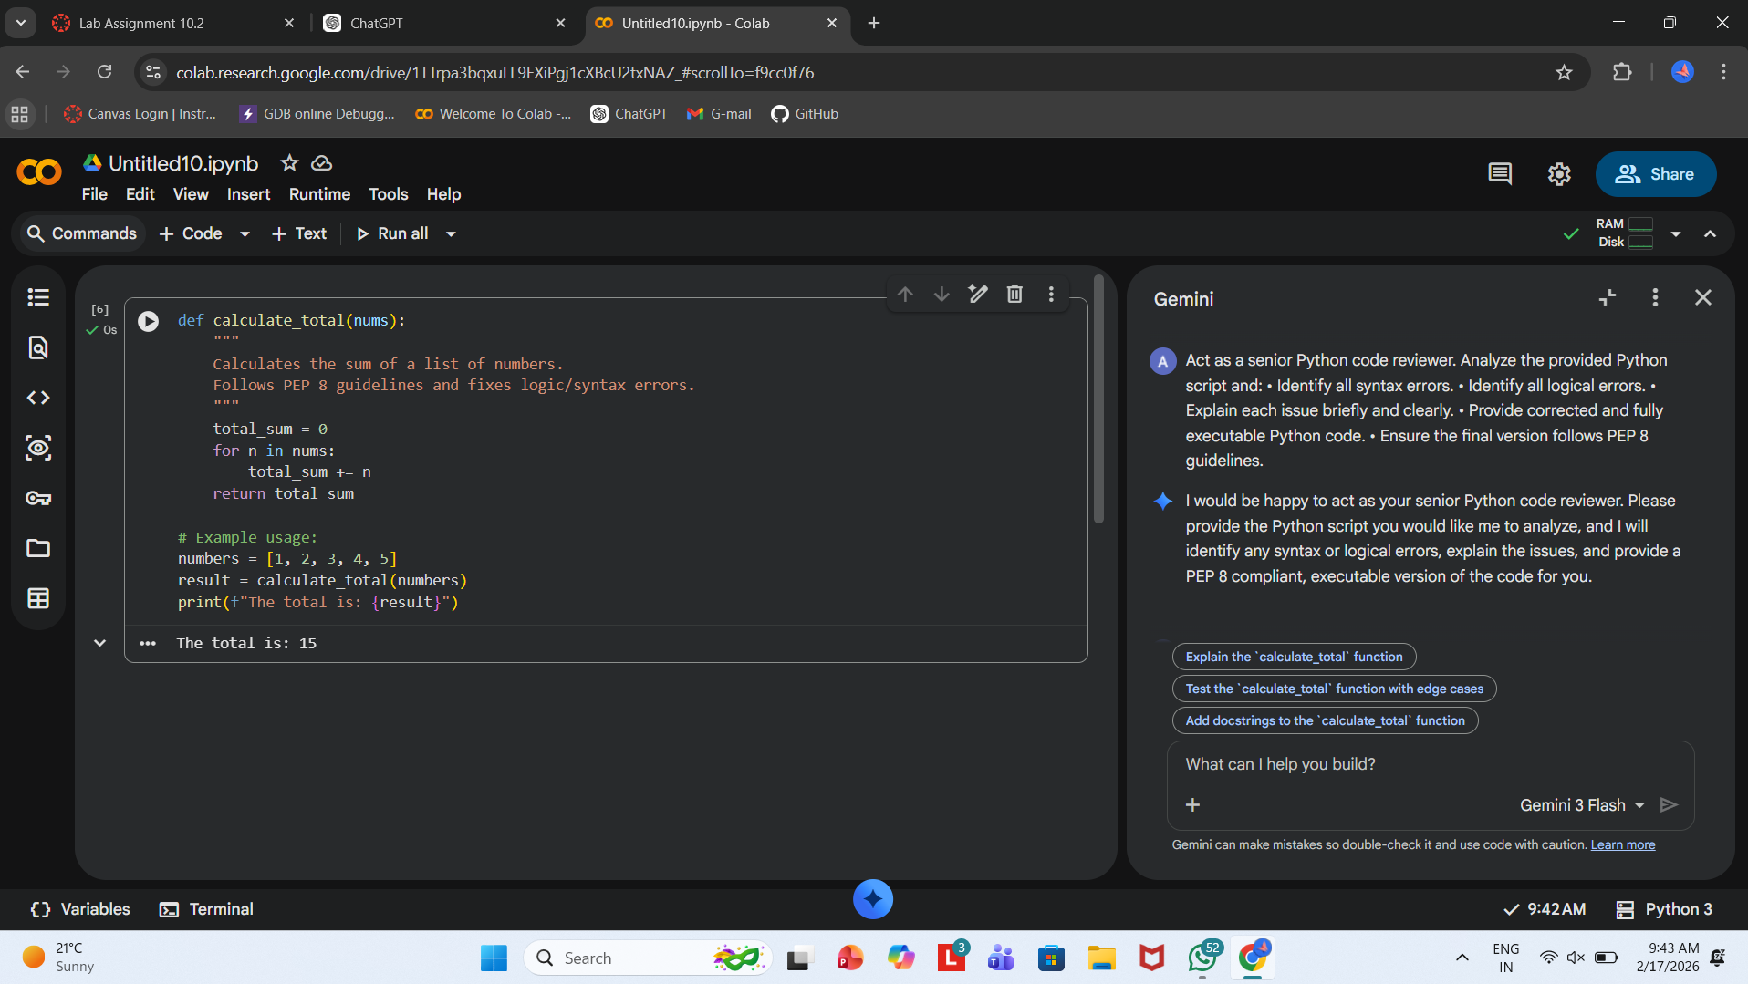

Task Description -2(Code Style Standardization)
Task:
Use AI to refactor Python code to comply with standard coding style
guidelines.
Sample Input Code:
def findSum(a,b):return a+b
print(findSum(5,10))
Expected Output-2:
Well-structured, consistently formatted Python code following standard
style conventions.
PROMPT :
Act as a Python style and quality expert.
Refactor the following Python code to comply with PEP 8 standards.
Improve formatting, naming conventions, spacing, and structure.
Add a proper docstring and ensure readability.
Original Code:
def findSum(a,b):return a+b
print(findSum(5,10))
Return only the improved Python code.
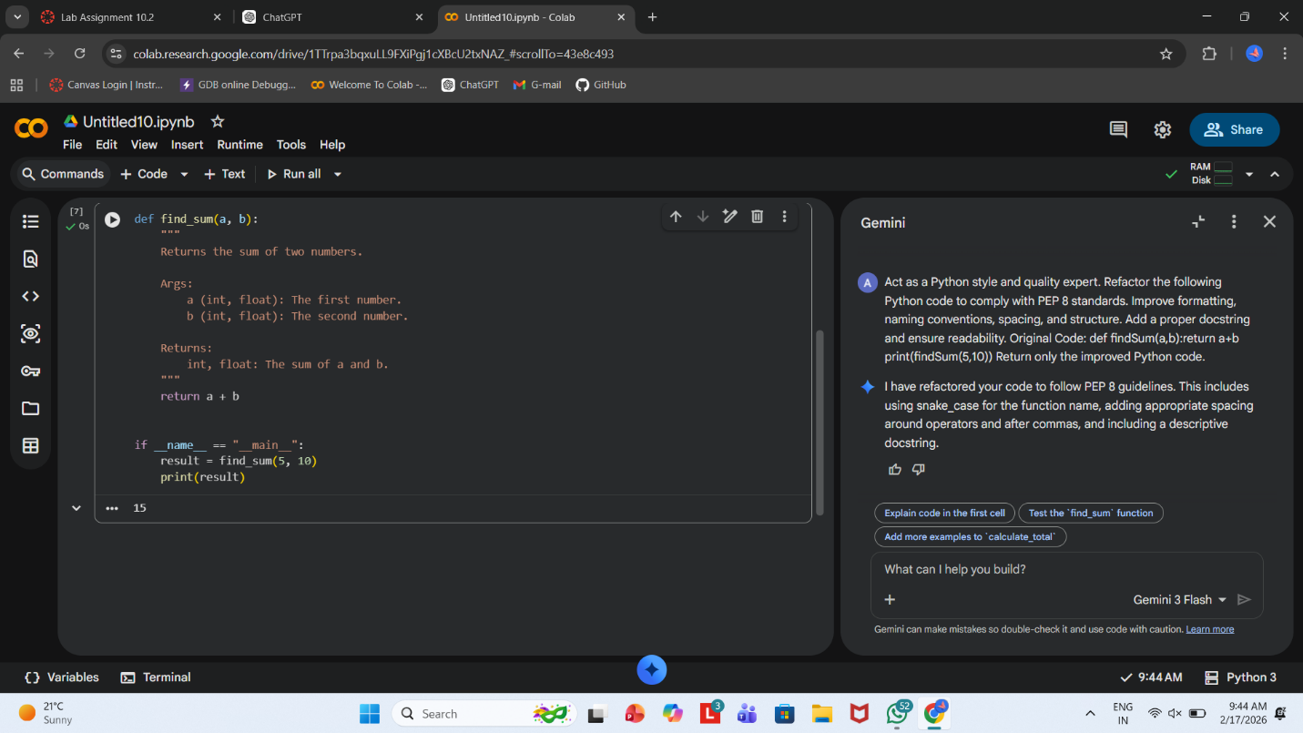

Task Description -3(Code Clarity Improvement)
Task:
Use AI to improve code readability without changing its functionality.
Sample Input Code:
def f(x,y):
return x-y*2
print(f(10,3))
Expected Output-3:
Python code rewritten with meaningful function and variable names,
proper indentation, and improved clarity.
PROMPT :
Act as a software engineer focused on clean code principles.
Rewrite the following Python code to improve readability and clarity
without changing its functionality.
Requirements:
- Use meaningful function and variable names.
- Add a descriptive docstring.
- Improve indentation and formatting.
- Follow PEP 8 guidelines.
Code:
def f(x,y):
return x-y*2
print(f(10,3))
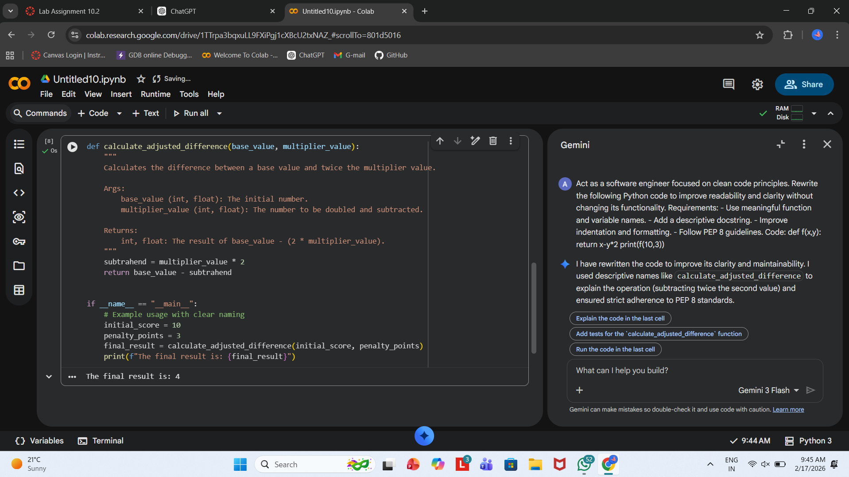
Task Description -4(Structural Refactoring)
Task:
Use AI to refactor repetitive code into reusable functions.
Sample Input Code:
print("Hello Ram")
print("Hello Sita")
print("Hello Ravi")
Expected Output-4:
Modular Python code using reusable functions to eliminate repetition.
PROMPT :
Act as a Python refactoring expert.
Refactor the following repetitive Python code into reusable and modular code.
Requirements:
- Eliminate repetition.
- Use a reusable function.
- Make the solution scalable.
- Follow best practices and PEP 8 style.
Code:
print("Hello Ram")
print("Hello Sita")
print("Hello Ravi")
Return the improved Python code with a brief explanation.
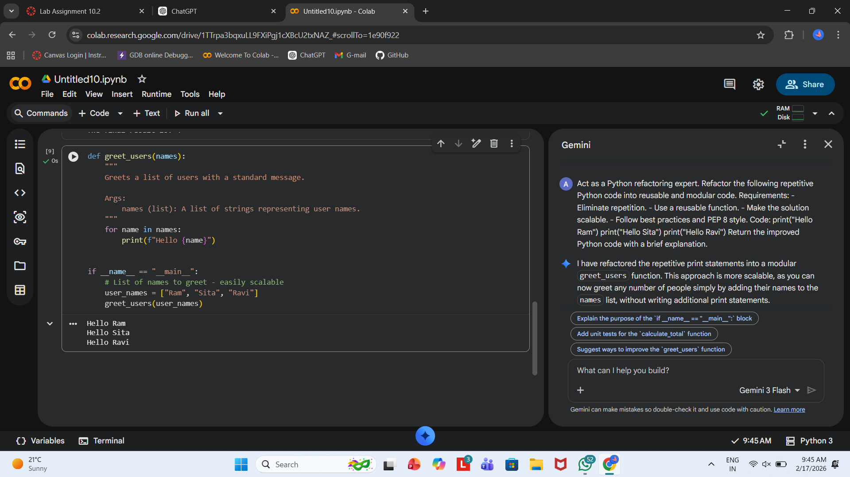
Task Description -5(Efficiency Enhancement)
Task:
Use AI to optimize Python code for better performance.
Sample Input Code:
numbers = [ ]
for i in range(1, 500000):
numbers.append(i * i)
print(len(numbers))
Expected Output-5:
Optimized Python code that achieves the same result with improved
performance.
PROMPT :
Act as a Python performance optimization expert.
Analyze the following code and optimize it for better performance and memory efficiency.
Requirements:
- Keep the functionality the same.
- Improve speed and/or memory usage.
- Use Pythonic techniques where appropriate.
- Briefly explain why your solution is more efficient.
Code:
numbers = []
for i in range(1, 500000):
numbers.append(i * i)
print(len(numbers))
